**36.336 (Woods) WSMR Uplink Room Computer Instructions** (last updated 9/4/21)

**Table of Contents**

**Hardware Setup** **1**

Layout of Computers 2

Personnel Assignments 2

RocketNUC3 – DataView Uplink & Hydra Secondary Instruments Display Hardware 3

MacD3921 – TM1 IDL Display, ESP/MEGS-P/HK Monitors IDL Display Hardware 4

Rocket9 Mac3202– EVE/MEGS CCD Images IDL Display Hardware 5

**Software Setup** **6**

RocketNUC3 – DataView Uplink & Hydra Secondary Instruments Display Software 6

MacD3921 – TM1 IDL Display, ESP/MEGS-P/HK Monitors IDL Display Software 10

Rocket9 MacD3202 – EVE/MEGS CCD Images IDL Display Software 13

Personal Laptop – Flare Watch Software 15

TM-1 Altair Software 16

TM-2 Altair Software 17

**Appendix: Software Screenshots** **18**

# Hardware Setup

## Layout of Computers

Downlinks: TM1 @ 5 Mbps: housekeeping, serial data for ESP, MEGS-P, XRS, OWLS

TM2 @ 10 Mbps: MEGS-A, MEGS-B

TM3: Onboard external cameras

Setup for 36.353 (see figure below) from left to right when facing table:

* SPARCS Commands (to left of picture)
* Flare Watch (personal laptop with internet connection & web browser)
* NSROC TM1 and TM2 (Altairs running DeweSoft)
* TM2 MEGS Images (Rocket9 MacD3202 running IDL)
* TM1 Monitors and ESP (MacD3921 running IDL)
* TM1-Serial (RocketNUC3 with 2 displays): XRS/OWLS/X55 (Hydra) on left, FPGA Uplink Commands on right

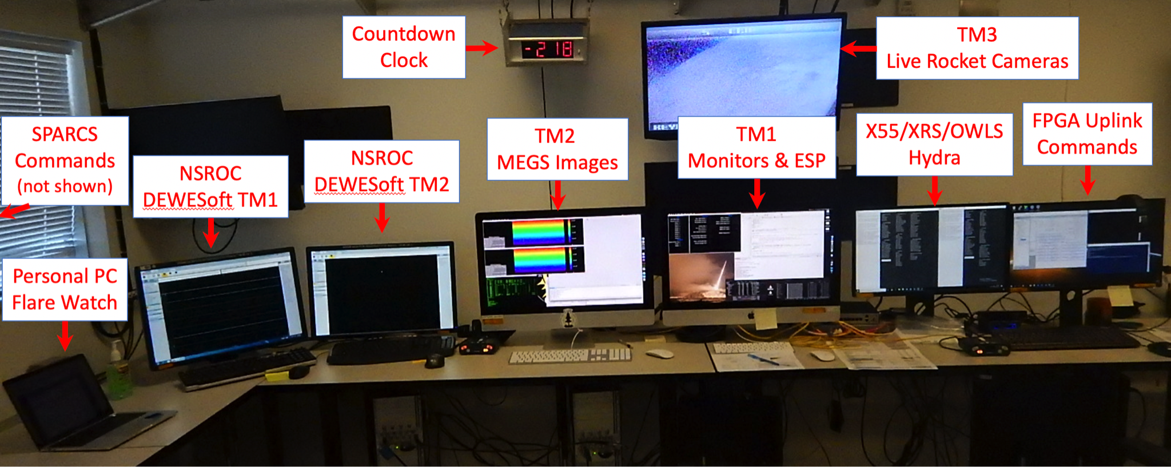

## Personnel Assignments

SOC LASP Personnel planned for 33.353 (as of 8/31/21), see figure below:

* SOC Manager: Primary: Frank Eparvier, Backup: Andrew Jones
* SPARCS: Primary: Andrew Jones, Backup: Frank Eparvier
* Flare Watch: Primary: Andrew Jones, Backup: Frank Eparvier
* TM2 MEGS Images: Primary: Brian Templeman, Backup: Robert Sewell
* TM1 Monitors & ESP: Primary: Robert Sewell, Backup: Brian Templeman
* X55/XRS/OWLS Hydra: Primary: Bennet Schwab, Backup: James Mason
* FPGA Uplink Commands: Primary: James Mason, Backup: Bennet Schwab

Blockhouse LASP GSE Personnel: Tom Woods, Rick Kohnert, Thad Barringer

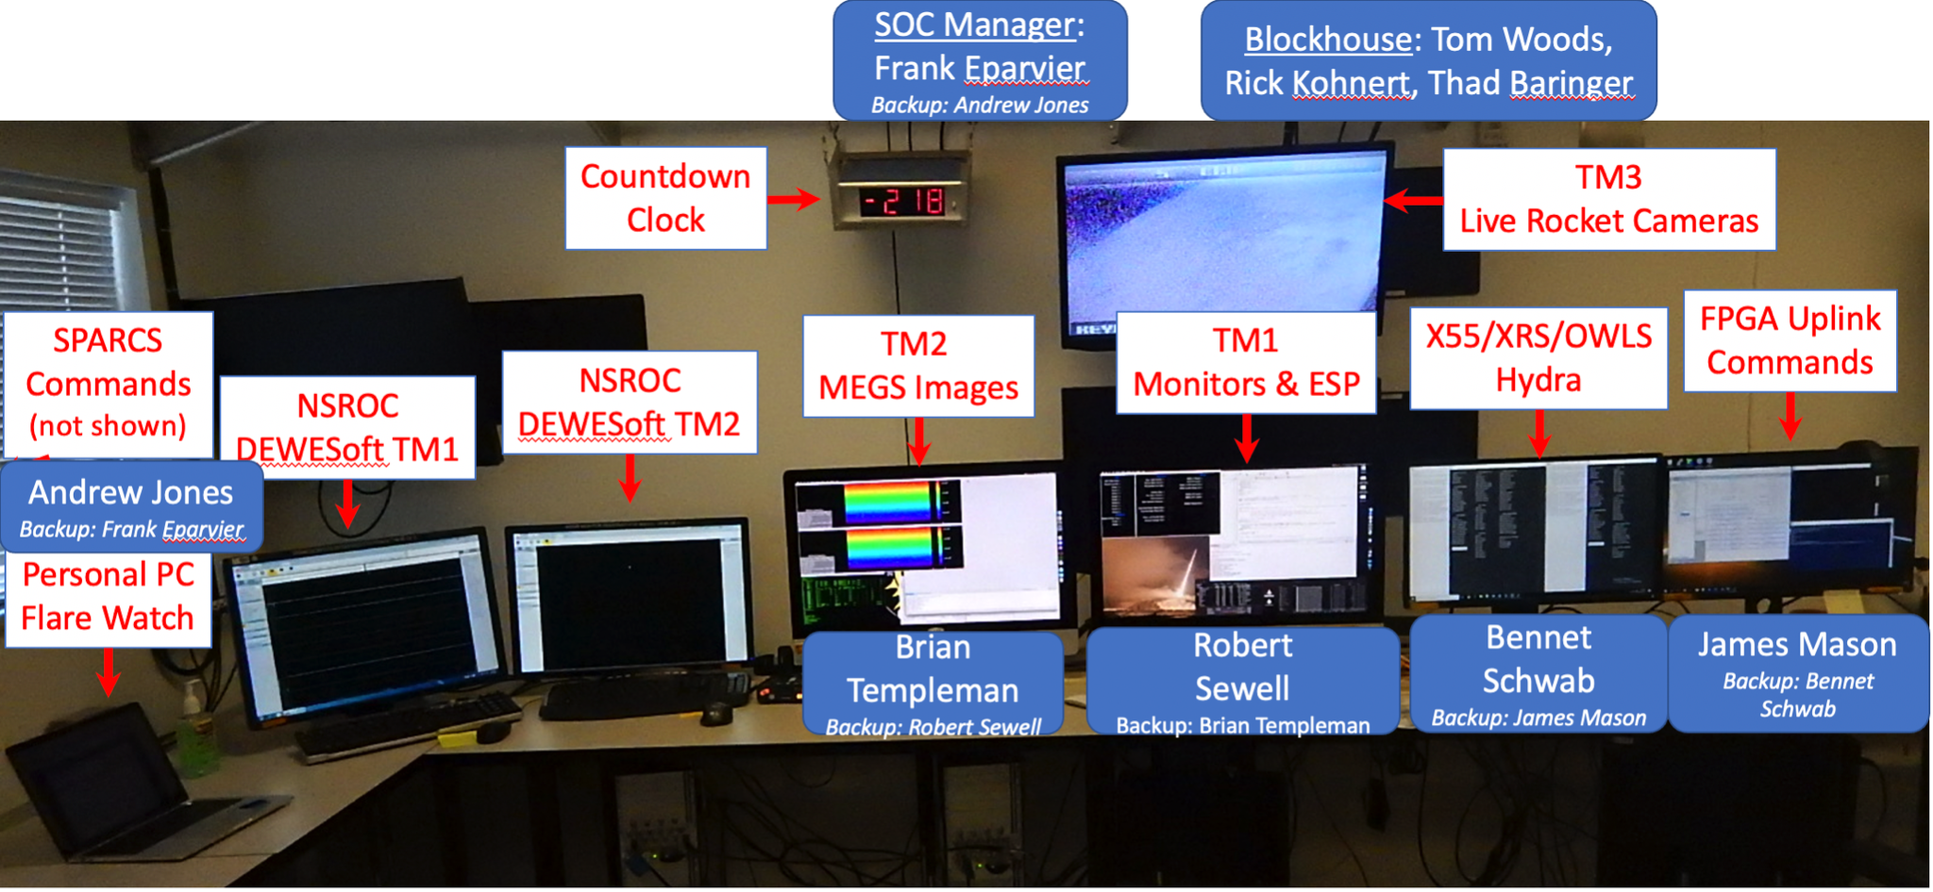

## RocketNUC3 – DataView Uplink & Hydra Secondary Instruments Display *Hardware*

RocketNUC3 is an Intel NUC computer with two monitors attached.

These are serial data, including housekeeping and some basic science measurements.

1. Network switch (BYO or NSROC can provide one from the warehouse outside the vertical assembly building, a Cisco Catalyst 2960G)
   1. Run an ethernet cable from RocketNUC3 to an open port on the network switch.
2. Coax cable bank on the wall
   1. From the bank of coax cables out of the wall, ask NSROC engineers for R9. They’ll plug a coax cable into the proper port and test it.
   2. Connect the coax to RS-232 converter.
   3. Connect a RS-232 to USB converter and plug into RocketNUC3.

**RocketNUC3 Setup Block Diagram**

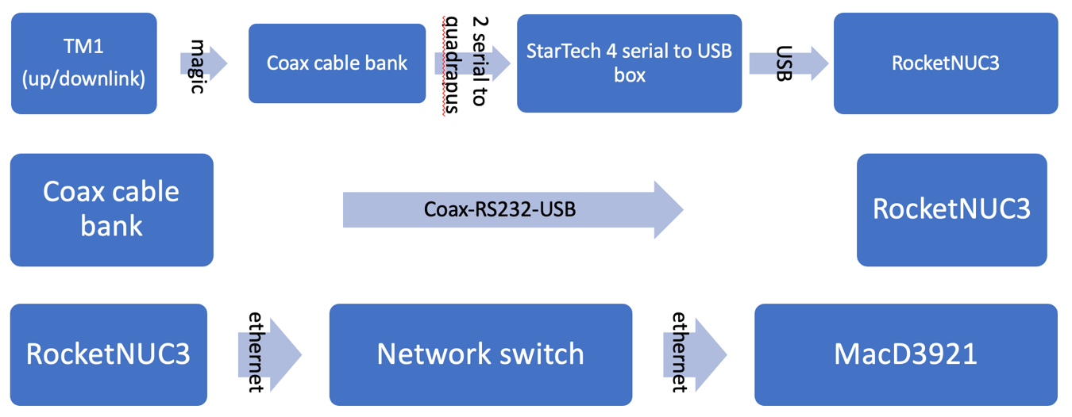

The StarTech serial box ports should be 8-bits, 1-stop-bit, no-handshaking.

1. Port 1: OWLS/EVEOP running 57600 baud. The other end of the cable is BNC to R15 (ask NSROC Bob which port this is assigned to on the coax bank on the wall).
2. Port 2: FPGA command uplink running 1200 baud. The cable also connects to Port 4 and the BNC to R1 (?).
3. Port 3: box – XRS+X55 running 57,600 baud. The other end of the cable is BNC to R14 (ask NSROC which port this is assigned to on the coax bank on the wall).
4. Port 4: FPGA downlink data running 1200 baud. This cable is spliced off from the one running into Port 2.

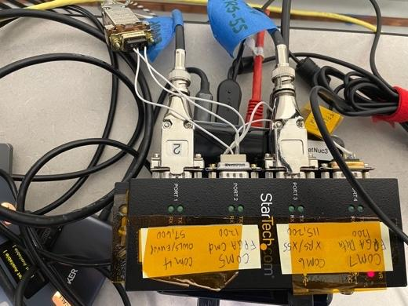

## MacD3921 – TM1 IDL Display, ESP/MEGS-P/HK Monitors IDL Display *Hardware*

MacD3921 a 27” 5K iMac.

TM1 has the analog and serial data (5 Mbps), including science data for ESP and MEGS-P and housekeeping for the overall payload.

1. Run an ethernet cable from MacD3921 to an open port on the network switch.

**MacD3921 Setup Block Diagram**

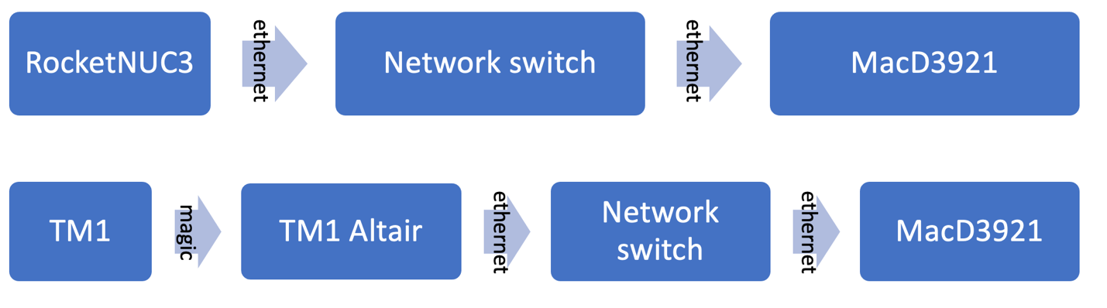

## 

## Rocket9 Mac3202– EVE/MEGS CCD Images IDL Display *Hardware*

Rocket 9 is a 27” 5K iMac; LASP computer name rocket9 MacD3202.

TM2 has parallel data (10 Mbps), including the EVE/MEGS CCDs (primary science data). In prior missions it also had data from XRI or CSOL on the “P3” channel; this flight there is no such instrument and **note that this caused issues for the TM radio lock because REVE FPGA fills that empty data with all 1s (it really should be filled with 0101010101).**

1. Run an ethernet cable from Rocket9 to an open port on the network switch.

**Rocket 9 Setup Block Diagram**

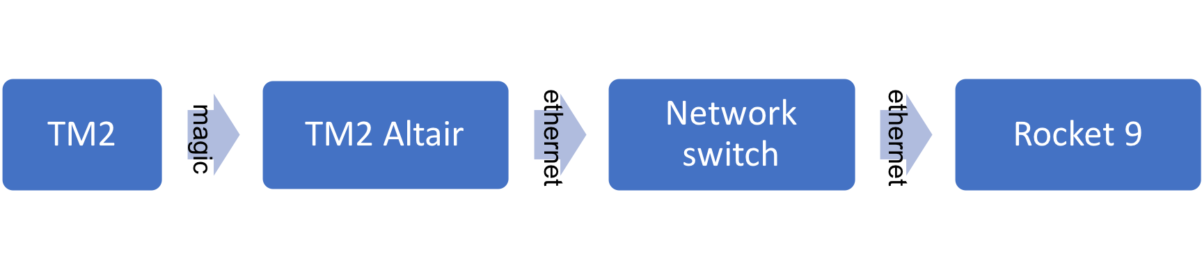

## 

# Software Setup

WiFi: lasp-eve-2.4GHz (or 5GHz). Password: EVERocks!F10. The desktop computers are all connected to a network switch + firewall that is also tied into our hotspot via ethernet, so they can access internet via ethernet rather than wifi.

## RocketNUC3 – DataView Uplink & Hydra Secondary Instruments Display *Software*

1. Login: rocket. Password: EVERocks!F10. If you have problems, try specifying the local domain as in the username input as RocketNUC3\rocket. For admin, use account RocketNUC3\rocketadmin and the same password.
2. A script will launch and configure all software for you (thanks Robert!)
   1. Start Windows Powershell by clicking on its Taskbar icon.
   2. Type C:\Users\rocket\Documents\FPGA_Dataview_and_Hydra_start then enter.
   3. If DataViewPC does not open the Definition File correctly, then select it through the File Open menu for the “Woods_36_353_FPGA_CMD_v7” file under the DataView_36.353 folder. Then run the “Startup_Script” in the Script menu. This will open a Dump File and the Limit Window with command buttons.
3. To close and start new Hydra dump files click the tlmOutFile rollover button.
4. On DataViewPC window, close and start new DataView dump file: in the Definitions window, expand (+) the Dump files folder and open (right click → Open) the Raw Dump option; this creates a log of all the raw input data. The filename is automatically populated; we ***typically add an additional “test name” identifier to the end***, e.g. (AutomaticFilename_VERTICALTEST). Files should be saved in the “Dump Files” subdirectory under the “DataView_36.353” main directory.
5. At power on of rocket EVE payload, the FPGA data will be displayed in both the COM7_PuTTY window and the DataViewPC window. For sending commands to the payload, we normally send the “MEGS TM Off” command first from DataView.
6. When done with test or flight, in Windows Powershell type C:\Users\rocket\Documents\FPGA_Dataview_and_Hydra_stop then enter.
   1. (WARNING: “X-ing” out of HYDRA causes it to crash. Must File > Close).

**IMPORTANT WATCH ITEMS for XRS Data Display**

***Filter Mechanism Position***:

Mechanisms: only trust Mech-2 hk. ~~01=Open. ~~10=Closed. Should be OPEN for flight

Commands to Open/Close can be sent by DataView uplink or GSE operator or by

internal Timer.

Mech-1 Encoders are not working and always have position flags of 00.

Each Open / Close command will list Current and Voltage in Hydra log window.

***Diode Data***:

XRS AXUV-100 Data Numbers (DN) are about 50 when dark.

XRS Quad Diode PS6 sum is converted to fC and is about 1000 fC when dark.

X55 Slow and Fast counts are about 5-10 counts.

XRS Position (from quad diodes, degrees) should be near (0, 0) when viewing the Sun.

*Aliveness Test: Rocket 5 Operator will turn on XRS LED.*

**RECOVERY for XRS and OWLS Hydra Data Displays**

Verify that HYDRA-Rocket for XRS is running OK – if not, then restart HYDRA-Rocket.

Verify that XRS is on (TM1 A7 XRS +5V Mon = 5.0 V when XRS is on).

Verify that X55 is on and the detector head is cooled (~240K)

SPA-OWLS Hydra:

Restart Hydra by clicking command + q and restart it by running SPA-OWLS_Hydra.app AppleScript

**Post-Test Processing for XRS**

Startup IDL on Rocket 7 and RUN xrs_read_packets.pro

**or** from IDL Console you can enter the following commands manually:

IDL> file = dialog_pickfile( /read, filter='tlm_packets*' )

Hydra tlm files are stored in

\User\rocket.rocket7\Documents\HYDRA_Rocket\Rundirs\ and

sorted by YYYY_DOY_HH_MM_SS folders when HYDRA started.

IDL> xrs_read_packets, file, hk=hk [, /verbose]

This will read the XRS file and return results in “hk”.

IDL> xrs_trend_plots, hk, /pdf

This will plot the HK variables into a PDF file

Report any questionable trends to M. Klapetzky and T. Woods.

RocketNUC3 runs an instance of DataView for commanding and PuTTY (for some command verifications).

**Commanding note:** Commands sent via the DataView window will display an acceptance message in the Putty window. Sometimes the commands need to be sent multiple times before being accepted because of the constant stream of MEGS analog monitors by FPGA (i.e., the FPGA can’t talk and listen at the same time).

1. See above for starting DataView via Powershell script.
2. When done with test or flight, select Action → Stop Processing. Close the dump file window to save the log file.

**IMPORTANT WATCH ITEMS for FPGA Command**

Most monitors should be Green.

Exceptions for being green are:

**CCD A Temperature** and **CCD B Temperature** will be **Red** until on the rail until we take the CCDs cold the day of launch.

CCDs will be cooled down T-6 hours from launch

CCD cooled temperature is about -50C to -60C = 223 K to 213 K

**RECOVERY for FPGA Command**

Verify that DataView is processing data (control-T).

Check that SPARCS, Ground Station, TM Uplink Systems are On and Ready.

Check that the serial connectors did not come loose on the Tripp-Lite USB-QuadSerial box.

It’s never been required, but you could stop / restart DataView for FPGA Command.

**Post-Test Processing for FPGA Command**

None unless there is concern with rocket CMD box performance.

DataView dump file is stored in

\Users\rocket\Documents\DataView\DumpFiles\ folder.

One can play back (Source File) in DataView.

**IMPORTANT WATCH ITEMS for FPGA Data (PuTTY)**

Command confirmation message will be displayed in PuTTY after sending command in the DataView FPGA Command window.

The MEGS TM (voltage / current monitors) should be turned OFF except when taking a MEGS TM sample; else it is difficult to get commands through.

**RECOVERY for FPGA Data (PuTTY)**

Verify that Rocket Experiment is turned On.

Check that SPARCS, Ground Station, TM Uplink Systems are On and Ready.

Check that the serial connectors did not come loose on the Tripp-Lite USB-QuadSerial box.

It’s never been required, but you could stop / restart PuTTY for FPGA Data.

**Post-Test Processing for FPGA Data (PuTTY)**

None unless there is concern with test command history or MEGS CCD TM data.

FPGA log from PuTTY is stored in

\Users\rocket\Documents\Rockets Documents and Data\putty_log\ folder.

## MacD3921 – TM1 IDL Display, ESP/MEGS-P/HK Monitors IDL Display *Software*

1. Login: rocketadmin. Password: EVERocks!F10
2. Start IDL 8.7 (it’s in the Dock).
   1. WARNING: IDL 8.8 WILL NOT WORK. It’s processing is 5x slower to draw. We actually had to downgrade to IDL 8.7 to get telemetry to display without 5-60+ seconds of lag.
3. Make sure that the DEWEsoftX2 TM1 application on the TM1 Altair is running and in setup mode, if not, stop and restart DEWEsoftX2 before proceeding.
4. Launch the rocket_tm1_start.app on the Mac desktop. This is a compiled Apple Script from Dropbox/minxss_dropbox/code/rocket_real_time.
5. When done, launch the rocket_tm1_stop.app on the desktop. This is a compiled Apple Script from Dropbox/minxss_dropbox/code/rocket_real_time.
6. Every time you run, a csv file will be created in Dropbox/ minxss_dropbox/data/reve_36_353/tm1_files/. If you just ran a sequence test or you want to validate the flight timers on this data you will want to run rocket_sequence_timer_validate.pro in the IDL IDE. To run it do the following:
   1. In the IDL Console type rocket_sequence_timer_validate, ‘analog_monitors.csv’ where analog_monitors.csv is whatever csv file was created during your sequence test.
   2. The program will output to the console the events it expected to see at each T+ time and if it actually saw that.
   3. If there are any timing errors noticed by the script simply plot the data that data that was pulled from the CSV file and inspect the telemetry manually for what you anticipated to see.

**IMPORTANT WATCH ITEMS for ESP and XRS+OWLS**

ESP/MEGS-P Diodes and HK Monitors:

If DEWEsoft packets are in an invalid format and the Serial and Analog Monitors are stale this will be indicated by the Last Full Refresh text turning purple. You do not need to do anything if this happens as processing will pick back up when the next valid packet comes in and the Last Full Refresh text will turn back to blue. If this does persist longer than a minute, however, contact a NSROC TM person.

Make sure you know which timed and commanded events will change which monitors. Some important ones of note are as follows:

When we go to internal power Exp Bus Cur should go from 0 to ~1.2

During ESP cals you should see the Diodes read ~??????

When we turn off OWLS XRS is also turned off so you will see the XRS +5V monitor go to 0

XRS-X55 Hydra:

The XRS-C is a visible quad diode (PS-6) solar position monitor. The XRS AXUV-100 is actually three photometers (filter + AXUV-100) with Ly-alpha, and the XRS-A and XRS-B channels, plus a dark diode. The Amptek X55 replaces the previously flown X123. None of these have flown before, so signal levels are unknown.

OWLS Hydra:

The OWLS is similar to the XRS in that it has a visible quad diode (PS-6) solar position monitor, three EUVOP filtered AXUV-100 diodes, plus a dark diode. OWLS has not flown before, so signal levels are unknown.

**RECOVERY**

ESP/MEGS-P Diodes and HK Monitors (TM1):

If the program crashes or hangs for any reason, do the following:

1. ) Make sure the IDL console is active

2.) Run rocket_tm1_stop.app

3.) Once that finishes you can restart processing by running rocket_tm1_start.app making sure that the IDL console is still active

4.) If Steps 1-3 do not work, the best procedure is to repeat steps 1-2, then quit IDL, stop and restart the TM1Altair DEWEsoftX2, relaunch IDL, and run the rocket_tm1_start.app.

5.) If the steps in 4 do not work, you may have to reboot both the Altair and the Mac.

## 

If you’re seeing behavior inconsistent with anything in this documentation, contact Robert Sewell at 720-288-4208 or James Mason at 209-221-3766 ([robert.sewell@lasp.colorado.edu](mailto:robert.sewell@lasp.colorado.edu) or [jmason86@gmail.com](mailto:jmason86@gmail.com) ).

## Rocket9 MacD3202 – EVE/MEGS CCD Images IDL Display *Software*

1. **FOR FLIGHT: MAKE SURE TO CHANGE APPLE SCRIPT TO REMOVE /NOMOD256 KEYWORD IN CALL TO IDL.** It is there for pre-launch tests when the CCD is warm but makes solar data hard to see.
2. Login: rocket. Password: EVERocks!F10. If you need admin, the account username is rocketad and the password is still EVERocks!F10.
3. Start IDL.
4. Double-click the rocket_tm2_start.app on the Desktop (AppleScript is in the file: /Users/rocket/Dropbox/minxss_dropbox/code/rocket_real_time )
5. When done, double-click the rocket_tm_stop.app on the Desktop.

**IMPORTANT WATCH ITEMS for Rocket 9**

If MEGS is powered on and TM is up and then you start the IDL processing, it will pick up immediately and you’ll see a wacky partial but the next full image will come across fine.

The red, and blue arrows should be ~constantly scrolling along the sides of the MEGS CCD images

It should take 8 seconds to complete one image pair, then a 2 second pause.

The IDL console will output some statistics when there are dropped TM packets.

If you see large blocks of vertically alternating colors in the images, that’s likely due to TM packets dropped. Ask a NSROC TM person about this and they’ll keep you in the loop or show you where to look to verify.

TM is going to be turned on and off a lot. Keep your ears and eyes open for that (NSROC will tell you where to look). When TM is brought down, you **must disable the ALTAIR transfer** or you may have to reboot Rocket 9 and the ALTAIR to get normal communication re-established. See recovery instructions below if that happens.

Flat fields (FF) will look like a mostly solid color image for MEGS A and B (though it is difficult to spot if you are not watching the display right prior to FF).

The reverse clock (RC) should make each half of the CCD a slightly different ~solid color.

The test pattern (TP) should make each half of the CCD have slanted rainbow stripes.

The solar spectra should look like this:

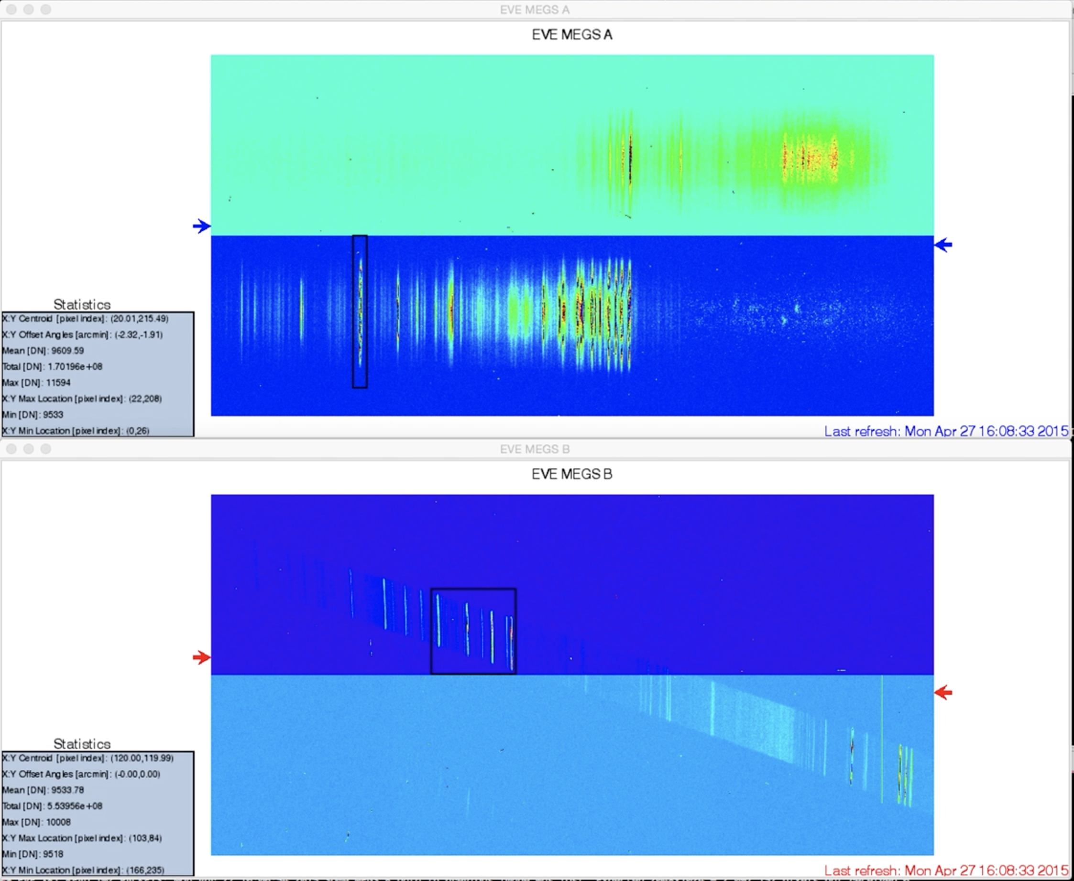

When you get your first couple solar spectra, look at the MEGS-A statistics box – X:Y Offset Angles [arcmin]. If the values are > 5, report to PI who will recommend a pitch or yaw maneuver.

**RECOVERY for Rocket 9**

If TM is brought down or MEGS is powered off while you’re processing the images, or if the program crashes or hangs for any reason, do the following:

1. ) Make sure the IDL console is active

2.) Run rocket_tm2_stop.app

3.) Once that finishes you can restart processing by running rocket_tm2_start.app making sure that the IDL console is still active

4.) If Steps 1-3 do not work, the best procedure is to repeat steps 1-2, then quit IDL, stop and restart the TM2 Altair DEWEsoftX2, relaunch IDL, and run the rocket_tm2_start.app.

5.) If the steps in 4 do not work, you may have to reboot both the Altair and the Mac.

If you’re seeing behavior inconsistent with anything in this documentation, contact James Mason at 209-221-3766 or Robert Sewell at 720-288-4208 ([jmason86@gmail.com](mailto:jmason86@gmail.com) or [robert.sewell@lasp.colorado.edu](mailto:robert.sewell@lasp.colorado.edu)).

## 

## Personal Laptop – Flare Watch *Software*

1. Open a web browser.
2. Open the site: <https://lasp.colorado.edu/eve/data_access/eve-space-weather/index.html>. Bookmark it for launch day.
3. Open the site: [gong.nso.edu/data/magmap/](http://gong.nso.edu/data/magmap/). Bookmark it for launch day.
4. Open the site: <http://sdowww.lmsal.com/suntoday_v2/> . Bookmark it for launch day.
5. Open the site: <https://www.swpc.noaa.gov/products/goes-x-ray-flux>. Bookmark it for launch day.

## 

## TM-1 Altair *Software*

This will most likely be setup by NSROC personnel.

1. Power switch is in the front left bottom.
2. Login
   1. user: Satille3
   2. pass: Nsroc1234!!!!! (note there are 5 !)
3. Open DeweSoftX2 Shortcut on the desktop. It’s configured to open our mission’s setup file on launch.
4. DeweSoft is ready to receive TM1 data (but needs to be configured by running rocket_tm1_start.app on MacD3921).

## 

## TM-2 Altair *Software*

This will most likely be setup by NSROC personnel.

1. Power switch is in the front left bottom.
2. Login
   1. user: VAB
   2. pass: Nsroc1234!!!!!!!!!!! (note there are 9 !)
3. Open DeweSoftX2 Shortcut on the desktop. It’s configured to open our mission’s setup file on launch.
4. DeweSoft is ready to receive TM2 data (but needs to be configured by running rocket_tm2_start.app on Rocket 9).

# 

# Appendix: Software Screenshots

**TM-2 Display**

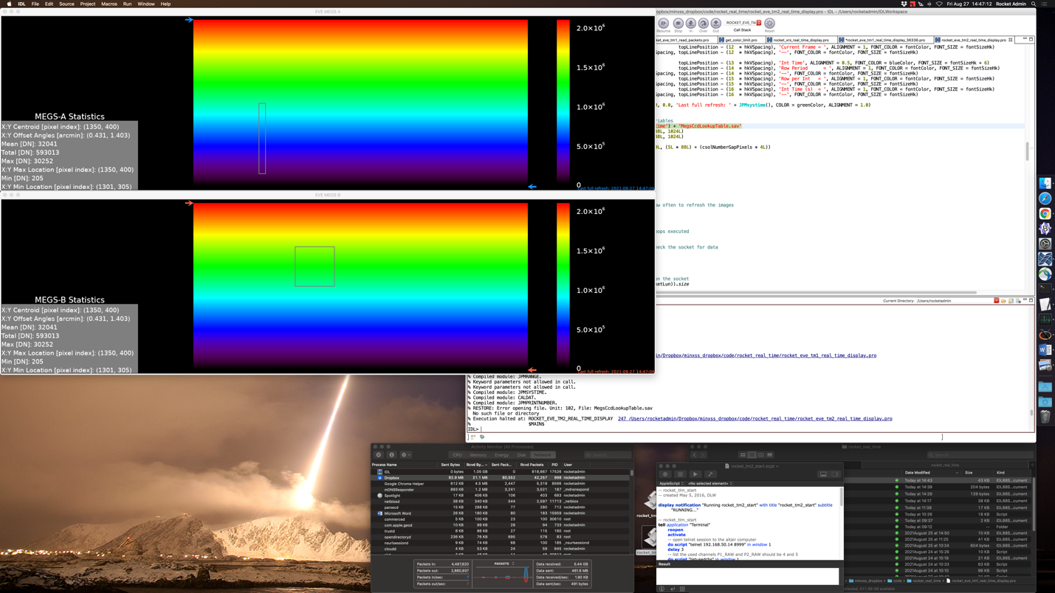

**TM-1 Display**

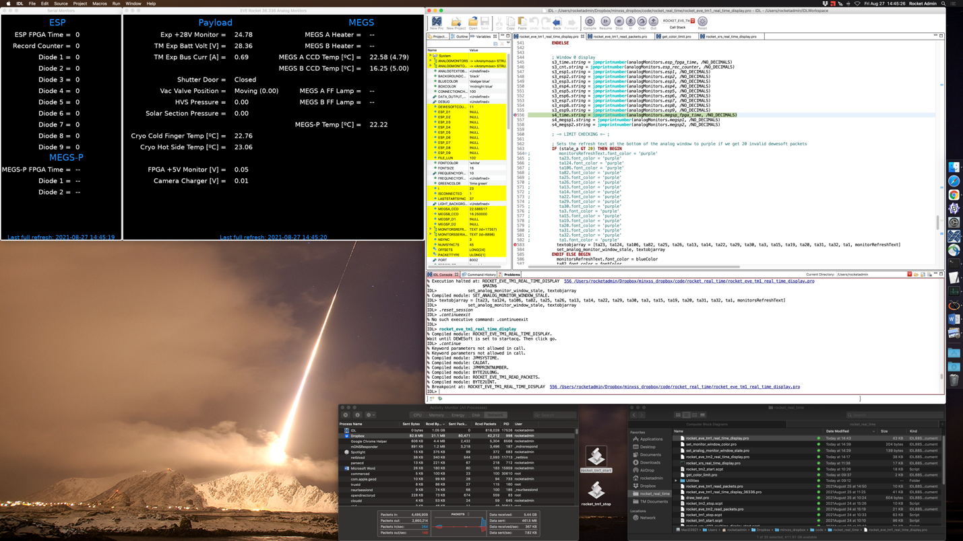

**RocketNUC3:** Left Display (XRS/OWLS Hydras)

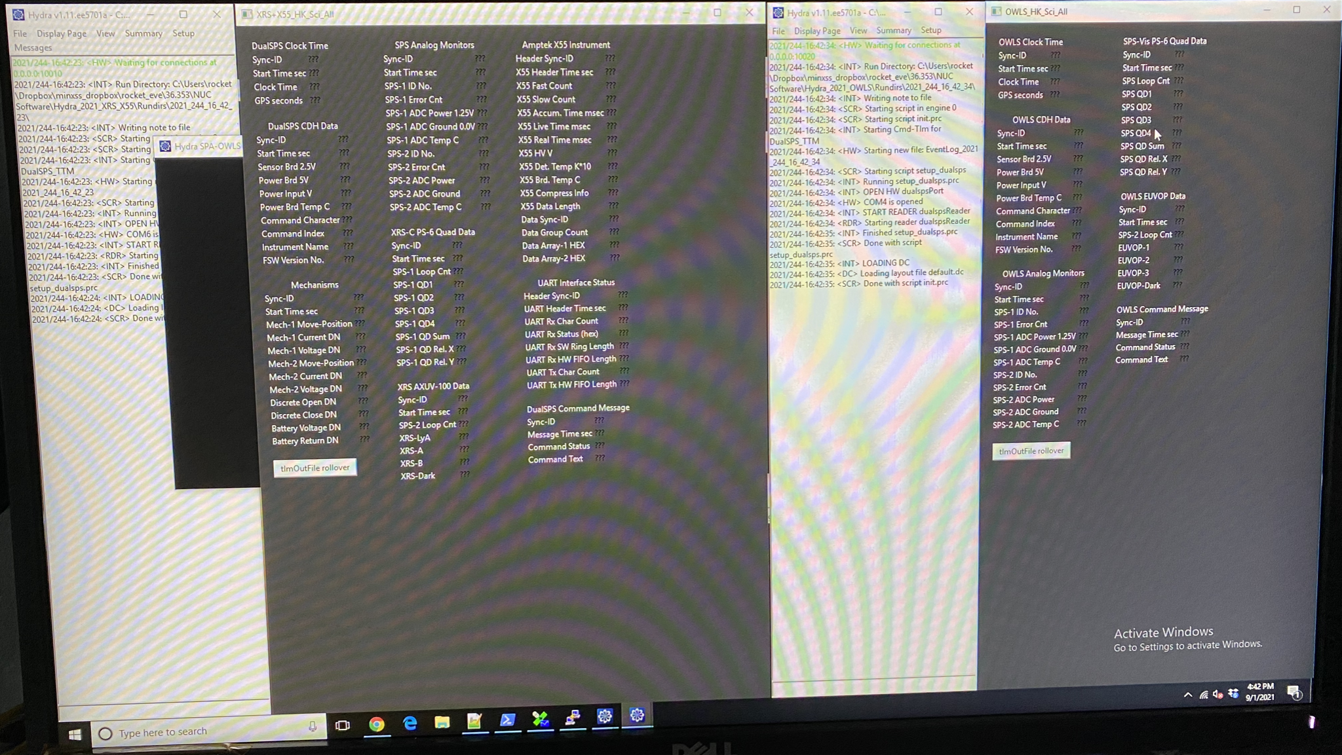

**RocketNUC3:** Right Display (FGPA Commands)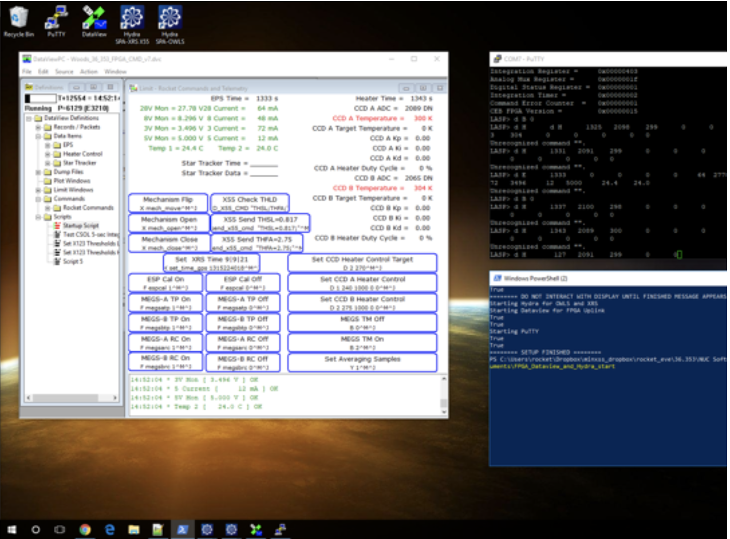

**Flare Watch**

